**4.1 Total number of Class Rooms(14) and Seminar Halls(02) = 16**

**Seminar Halls-02**

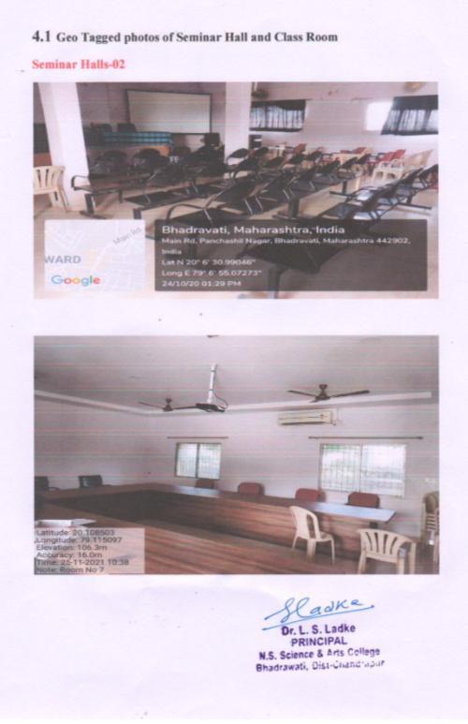

|  |
| --- |
| **Class Rooms – 14** |
| **3.JPG** |



  
  
  
  
  

  
  
  
  
  

  
  
  
  
  

  
  
  
  
  

  
  
  
  
  

  
  
  
  

  
  
  
  
  